* **RECEIPTS**

Product inventory receipts allow *SMIS* Orders to record and track your physical product inventory accurately and efficiently. Inventory receipts are recorded when a product is received in inventory, and receipts can be entered only for stock items that have an active, inactive, or outofproductionstatus.

When entering product inventory receipts, enter the transaction type, supplier, location, reference number from the supplier ,date received and delivery, quantity, cost and serial number received in inventory for a specific product. When an inventory receipt is entered, a transaction number is generated automatically as a reference for the receipt. When inventory receipts are finalized, *SMIS* automatically updates and adjusts your product inventory records.

To ensure accurate inventory records, manually posting inventory receipts is recommended because it provides an opportunity to review the receipts before they are finalized. This helps prevent entering any accidental updates or changes.

Your method of storage determines how inventory receipts are entered. If an individual product is stored in a single storage facility, you only need to enter a single inventory receipt for a product. If an individual product is stored in multiple warehouses, you have the ability to enter inventory receipts for each location in which a product is stored. In order to record inventory receipts for products stored in multiple locations, select the location in the drop down list of the receiving location field.

* **HOW TO START   
  1.) Click Menu  
  2.) Click Transactions  
  3.) Click Receipts**

Menu

Transactions

Receipts

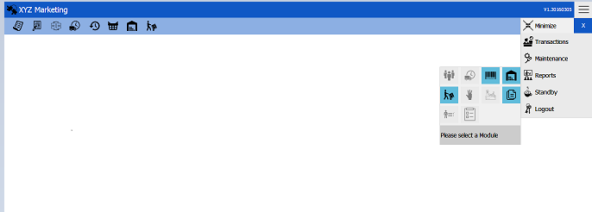

* **New Transaction:**

1. **Select a transaction type**
2. **Select a supplier**
3. **Select a receiving location**
4. **Input the reference number**
5. **Input the date of delivery**
6. **Search an item**
7. **Post transactions**
8. **Finalize transactions**

Reference Number

Post

Finalize

­­

Search

Date

Location

Supplier

Transaction type

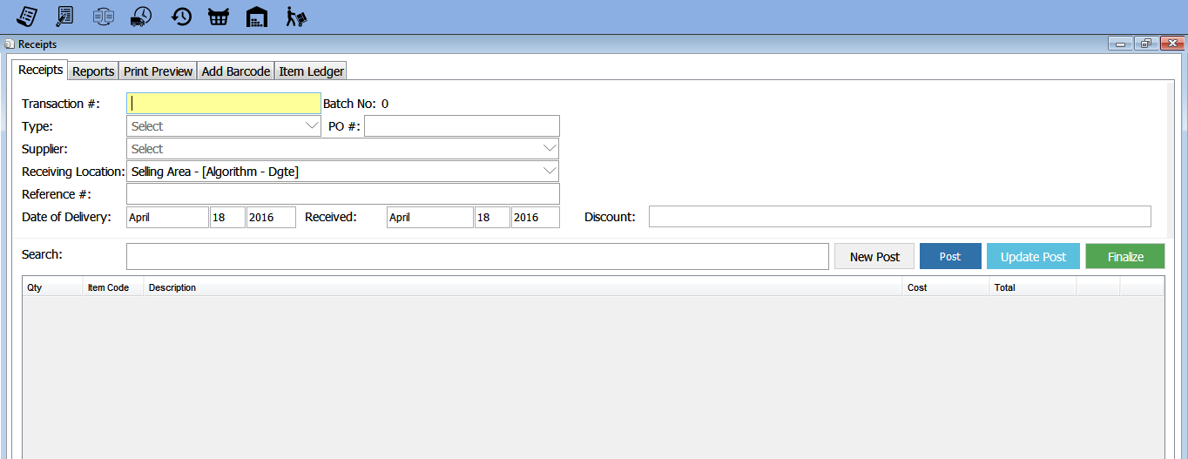

1. **Select Transaction Type**

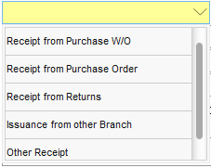

“By Default choose "Receipt from Purchase W/O"

1. **Select a Supplier**

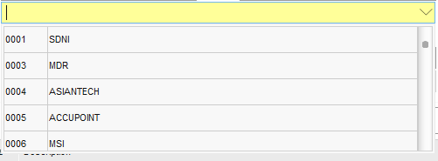

You can add a new supplier Under Maintenance. Go to Menu-> Maintenance -> Suppliers

1. **Select a receiving location**
2. **Select Location**

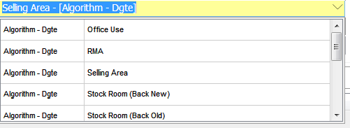

Upon opening the window, a default branch location will be displayed in the input box. Just choose a location if new stocks received will be placed to the other location.

1. **Reference number**
2. reference.PNG **Input reference number**

This is the transaction number given by the supplier upon receiving the receipt.

1. **Date of delivery**



Input the date when the stacks are delivered and received.

1. **Search an item**

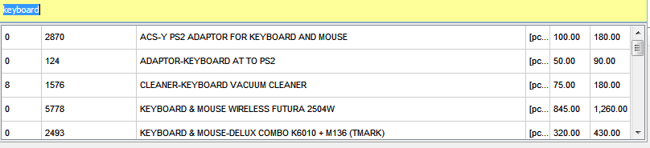

Item Searched

Number of Stocks Available

Item Code

Description

Unit of measure

Cost

Selling price

**Note: You can search item by using:**

1. **Item name/code**
2. **Barcode (Input/Scan)**
3. **Item description**

**6.1 Input the quantity and cost**

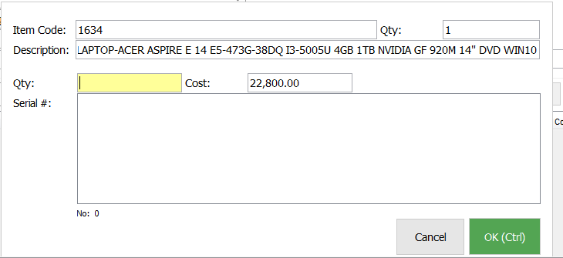

1. **Input the item quantity received**
2. **Input the item cost (supplier’s price)**
3. **Input/Scan Barcode each item’s serial number for future references.**
4. **Click OK to continue.**

**6.2 Update and delete item entry**



**Here, you can delete/update item by the list by just clicking the delete/update word.**

Click to delete the item

Click to update the item

1. **Post transactions**



After filling up the receipt details and item entry, click the “POST” button in the middle right corner of your window.

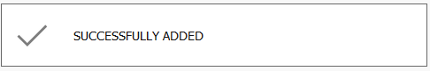

**A message will appear if you successfully posted**

* **Finalized Transaction**

1. **Finalized transactions**

**Note: A transaction needs to be reviewed and finalized in order for the item entry to be added in the inventory.**

**To do this, do the following steps:**

1. **Go to the “Reports tab”.**
2. **Search and select the transaction to be reviewed or finalized.**
3. **In the transactions table next to “Gross Total” column, a status of the transaction is delayed.**
4. **Right Click to finalize the transaction directly.**
5. **Review & finalized (Click the “Update” label)**

Print Preview

Item Status

Delete

Update

Search Filters

Reports Tab

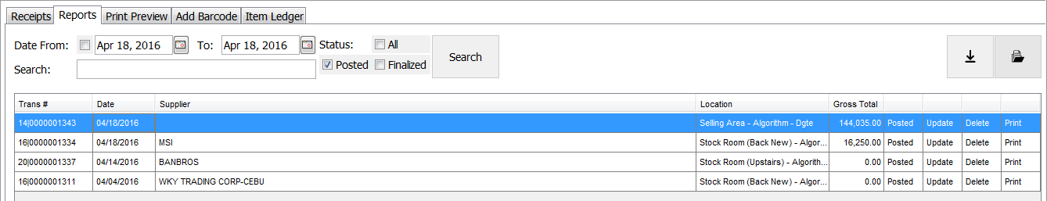

Item Status

List of Transactions

1. **Reports Tab – View Transactions**
2. **Search Filter**

2.1  **Date- Choose date intervals or select the checkbox to view transactions regardless of the date.**

2.2 **Status- Show transactions depending on the selected checkbox.(All/Posted/Finalized).**

2.3 **Search- Display transactions with transaction numbers that matches the search item.**

1. **Item Status- Displays transaction’s current status (Posted/Finalized). If posted, you can directly finalize the transaction. Just right click->click “Finalized Receipt”.**

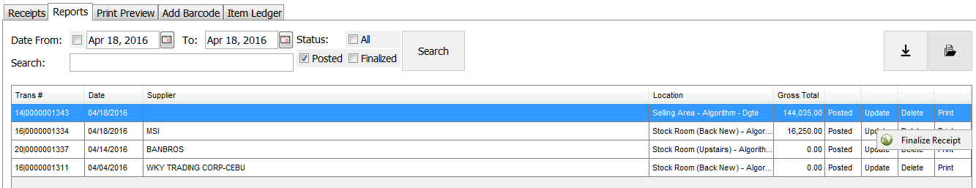

Note: **Only users who has the privilege can finalized the transaction**

1. 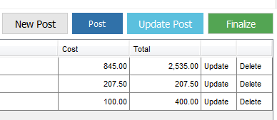**Update/Review – Click the “Update” label and you will be redirected to the “Receipts Tab”. Check and edit the transactions for wrong entries. Then click the “Finalized” button at the right corner of your screen.**
2. **Delete – It deletes posted transactions only. Finalized transactions cannot be deleted anymore.**
3. **Print Preview Tab – Shows the details of the transaction and the added items.**

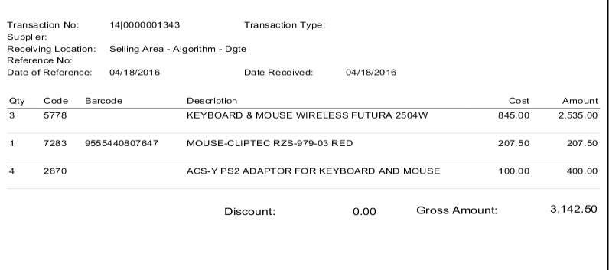

1. **List of Transactions- Shows the whole transaction’s list (Transaction #, Date, Supplier, Location and Gross Total).**

